**Administering Medication**

**Learning outcomes**

The Caregivers will learn:

1.1 What is administration of medicines

1.2 Different routes of administration of medicine

1.3 Post administration activities

**Right Way of Administering Medication**

**What is Administration of Medicine:**

* Administration of Medicine refers to dispensing of medicine or drug to a patient for remedial and/or diagnostic purposes
* Medicine Administration must be:
  + Right Patient
  + Right Drug/Medicine
  + Right Dose/Quantity
  + Right Time (as per the time chart)
  + Right Route
  + Right Method

**Note: Do not forget to check expiry date od medicine before use.**

**Routes of Administering Medication**

**There are various routes of administration of medicines:**

1. **Oral** –is the most common, convenient, less expensive and safe for most of the patients
2. **Sublingual -**– where a drug is placed under the tongue for faster absorption
3. **Buccal** – where a drug is placed between the gum and teeth for slow absorption
4. **Rectal-** drugs eg suppositories are administered rectally
5. **Vaginal** – drugs eg pessaries are administered vaginally
6. **Topical** –like, inhalation and nebulisation to carry the drug into lungs by breath, use of eye drop, steroids in the management of dermatitis are given by this method to have local or systemic effect
7. **Parenteral** – where it is giving of therapeutic agent outside the alimentary tracks; like intravenous, intramuscular, subcutaneous, etc.

**Oral** –**Administration**

Administration of medicine through mouth for prophylactic and therapeutic effects; Purpose:

1. Promote health
2. Prevent illness
3. Help in diagnosis
4. Alleviate illness or symptomatic pain

**Sublingual**

A few drugs are placed under the tongue (taken sublingually)

**Buccal**

between the gums and teeth (buccal); Purpose:

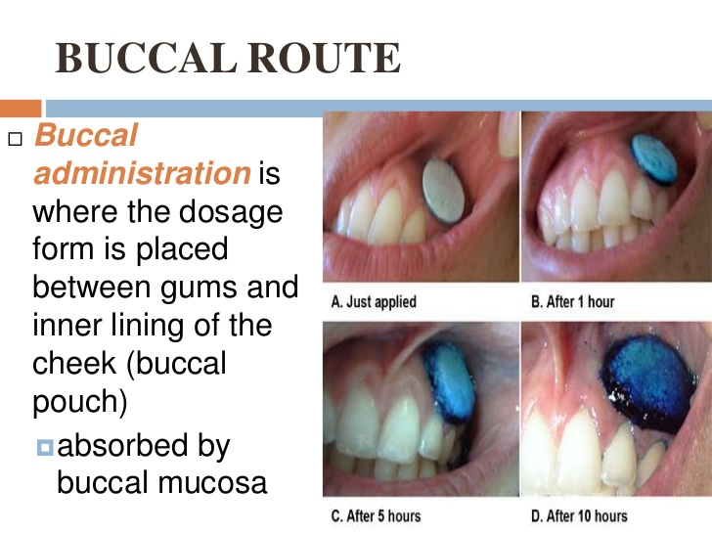

1. Dissolve directly in the blood vessels
2. Rapid absorption and drugs immediately enters the blood stream

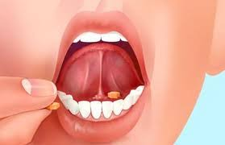

**Rectal and Vaginal**

Administered rectally as a suppository or as a solution, tablet, cream, gel, suppository, or ring through vagina; Purpose:

1. Drug is readily absorbed
2. Help people who cannot take drug orally

Require after many surgical operation

**Topical**

Like inhalation and nebulisation to carry the drug into lungs by breath, use of eye drop, steroids in the management of dermatitis, etc.; Purpose:

1. Smaller droplets go deeper
2. Increases the amount of drug absorbed

**Parenteral**

Means any non-oral means of administration, but is generally interpreted as relating to injecting directly into the body; Purpose:

1. Drug do not enter the gastrointestinal system
2. Faster absorption
3. Drugs go the bloodstream through intramuscular (IM), subcutaneous (SC) and intravenous (IV)

**Caution**

**Do not administer oral medicine:**

* For unconscious patient
* For uncooperative patient
* After oral and gastric surgeries
* Oral cancers
* Before diagnostic tests and operation

**General Instructions: Before Medication**

* Identify the patient by checking the medication card
* Check the physician’s prescription
* Check the label of the containers thrice
  + Before the medication container is taken from the shelf
  + Before pouring the drug
  + Before replacing the container in shelf
  + Check the expiry date of the drug
* Shake the liquid medicine before pouring it into ounce glass, pour it away from the label
* Wipe the mouth of the bottle, close it tightly and replace it at the proper place
* Hold the ounce glass at eye level & place the thumb on the neck of the ounce glass to which medicine is to be poured
* When taking tablets or capsules do not touch them with hands, drop them from the container to its lid and then to the medicine cup
* Do not put back the medicine once it is taken out of the container
* Do not use the medicine if there is a change in colour, odour or consistency
* Prepare the drugs just before the time of administration and do not leave the drug in the medicine tray without proper identification

**General Instructions: After Medication**

* Record only the medicine, which you have administered only
* Record the date, time, name and dose of the drug administered
* Never record a medicine before it is given
* Record the effect observed after medication, if any